fd;dpahFkhp khtl;lk;> Nj&h;(,)FyNrfud;GJ}h;> khtl;l Mrphpah; fy;tp
kw;Wk; gapw;rp epWtd Kjy;thpd; nray;Kiwfs;

Kd;dpiy.Kidth;. N[. [Pdh N[k;];

e.f.vz;. 286/</2017 ehs; 22-06-2017
------------------------------------------------------------------

nghUs; | : | gapw;rp - jkpo; tpf;fpg;gPbah NfhilKfhk; - Mrphpah;fSf;F jkpo; tpf;fpgPbah tiyjsj;jpy; jkpo; fl;Liufis vOj Cf;Ftpj;jy; rhh;ghd gapw;rp mspj;jy; - rhh;G.
ghh;it | : | nrd;id-06> khepyf; fy;tpapay; Muha;r;rp gapw;rp epWtd ,af;Fehpd; nray;Kiwfs; e.f.vz;. 1653/</2017> ehs; 16.06.2017.

-------------------------
ghh;itapy; fhZk; ,af;Fehpd; nray;Kiwfspd;gb jkpo; tpf;fpgPbah NfhilKfhk; ,izg;gpy; fhZk; Mrphpah;fSf;F jkpo;tpf;fpgPbah tiyjsj;jpy; jkpo; fl;Liufis vOj Cf;Ftpj;jy; rhh;ghd gapw;rp 28-06-2017 Kjy; 30-062017 tiu %d;W ehs;fs; fPo;fz;lthW eilngw cs;sJ.

ehs; | gq;Nfw;ghsh;fs; | ,lk; | g];&l;
28-06-2017 Kjy; 30.06.2017tiu  (3 ehs;fs;) | ,izg;gpy; fhZk; Mrphpah;fs; | DIET -Theroor | 30A, 34A, 50A, 33C, 34

,izg;gpy; fhZk; Mrphpah;fis rk;ke;jg;gl;lg; gs;spj; jiyikahrphpah;fs; cldbahf gzptpLtpg;G nra;jpl midj;J khtl;lf;fy;tp mYtyh;fs; jf;f mwpTiu toq;fpl md;Gld; Nfl;Lf; nfhs;fpNwd;.

Fwpg;G : 1. gq;Nfw;ghsh;fSf;F kjpa czT toq;fg;gLk;.
2. Laptop kw;Wk; Data Card cs;s Mrphpah;fs; gapw;rpf;F tUk;NghJ
nfhz;LtuTk;.

,izg;G :

- nrd;id-06> khepyf; fy;tpapay; Muha;r;rp kw;Wk; gapw;rp epWtd ,af;Fehpd; nray;Kiw fbj efy;.
- Mrphpah;fspd; ngah;gl;bay;.
efy; :
- Kjd;ikf; fy;tp mYtyh;
fd;dpahFkhp khtl;lk; - jftYf;fhf md;Gld; njhptj;Jf; nfhs;fpNwd;.
- midj;J khtl;lf;fy;tp mYtyh;fs;>
jf;f eltbf;iff;fhf md;Gld; mDg;gg;gLfpwJ.
- rk;ke;jg;gl;l gs;spj; jiyikahrphpah;fs; ,izg;gpy; fhZk; Mrphpah;fis cld; gzptpLtpg;G nra;jpl Nfl;Lf; nfhs;sg;gLfpwhh;fs;.

Kjy;th;(ngh)>
khtl;l Mrphpah; fy;tp
kw;Wk; gapw;rp epWtdk;>
Nj&h;(,)FyNrfud;GJ}h;>
fd;dpahFkhp khtl;lk;

25 | Sabitha  GHSS Ammandivilai | Maths | 9486447339
26 | M.Sahaya Jessie  St.Antonys HSS Kanyakumari | Science | 9043464393
27 | A.Effie  GHS Ezhakaram | Science | 8870924211
28 | V.Thangamalar  GHS Mahadhanapuram | Science | 8695058796
29 | Suba  GHS Kottayadi | Science | 9994817732
30 | P.KirubhaJini  GHS Koduppaikuzhi | Science | 9442949791
31 | A.S. Baby Chitra  GHS Ananthapuram | Maths | 7299521896
32 | Muthupriya  GHS Nalloor | Science | 9944810036
33 | Z.Immaculate Jessy  St.Joseph Convent HSS, Nagercoil | Science | 9843537848
34 | S.Ponkasi  GHS Variyoor | Social Science | 9487888982

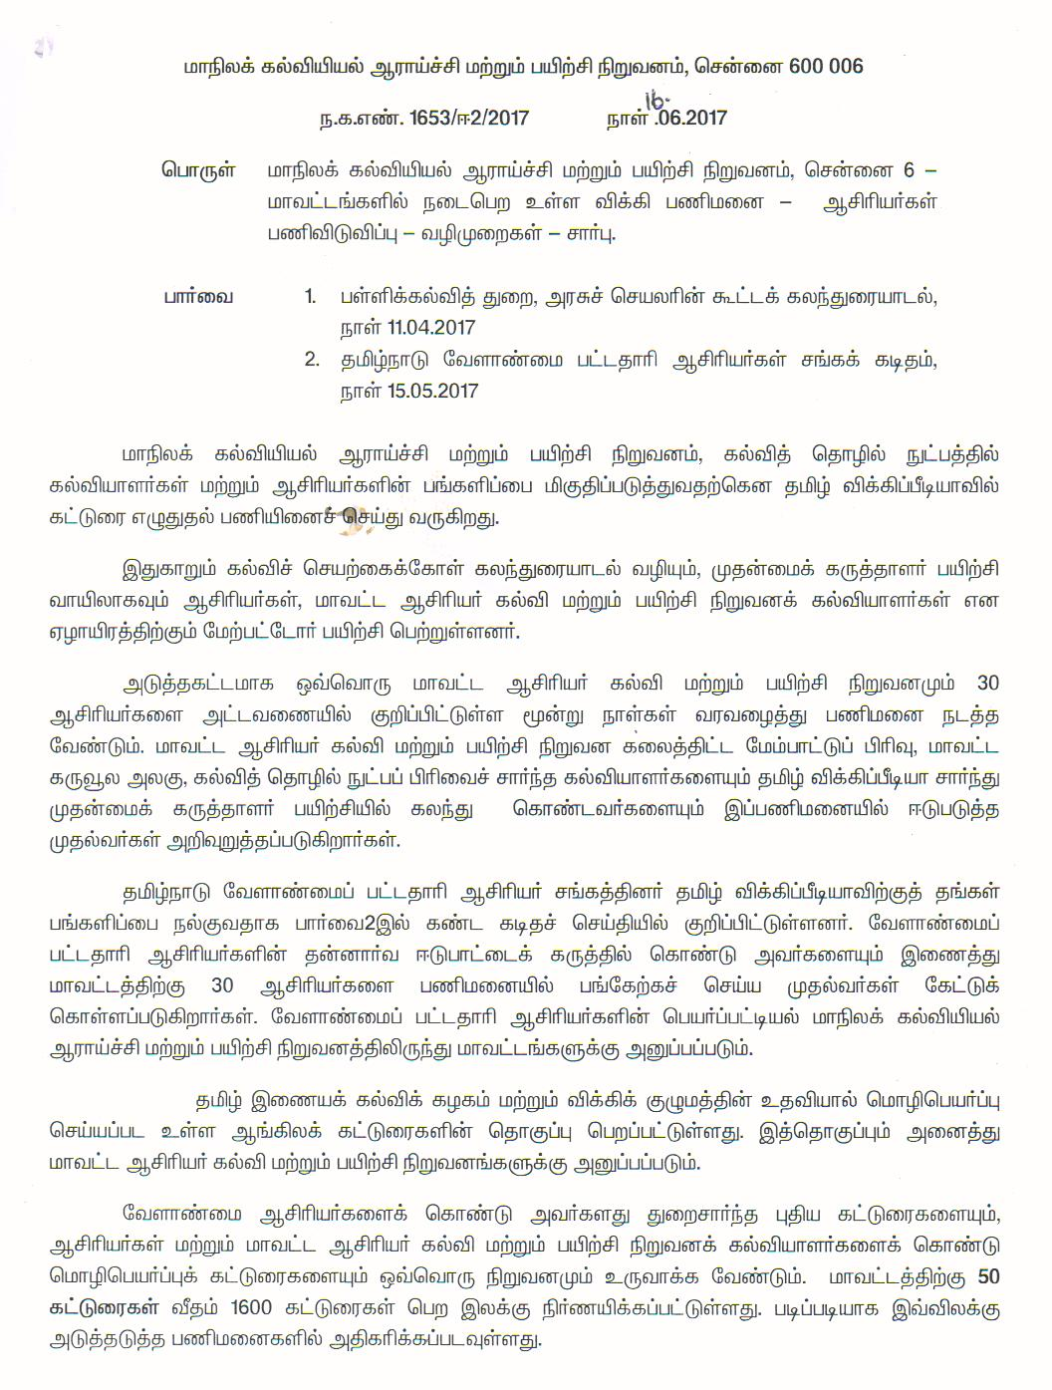

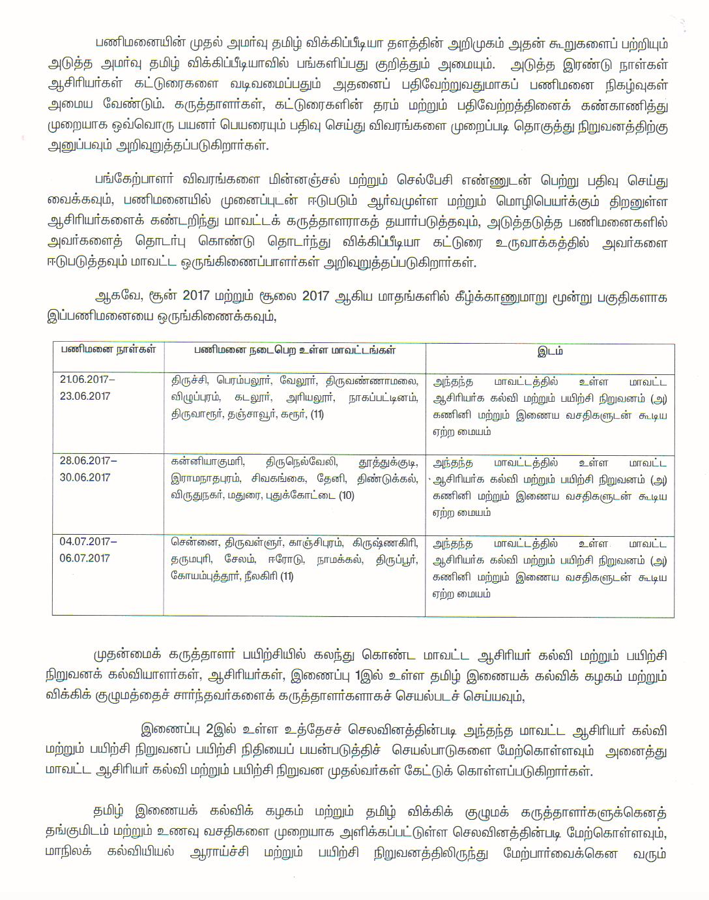

,af;Feh;

